Auckland Council's position and role in affordable housing - affordable homes for all

**File No.:** CP2019/01778

Meet the [Quality Advice Standards](https://acintranet.aklc.govt.nz/EN/planspoliciesreports/qphub/Documents/Qualityadvicestandards.pdf) and use the [template reference document](https://acintranet.aklc.govt.nz/EN/planspoliciesreports/qphub/Documents/Template%20reference%20document.pdf) for assistance.

**Te take mō te pūrongo**

# Purpose of the report [guidance](https://acintranet.aklc.govt.nz/EN/workingatcouncil/techandtools/infocouncil/Pages/PurposeOfTheReport.aspx)

1. To decide on Auckland Council’s position and role in affordable housing.

**Whakarāpopototanga matua**

# Executive summary [guidance](https://acintranet.aklc.govt.nz/EN/workingatcouncil/techandtools/infocouncil/Pages/ExecutiveSummary.aspx)

1. Housing is increasingly unaffordable for a growing number of households in Tāmaki Makaurau. One third of Auckland renters spend more than 30 per cent of their income on housing costs. They are ineligible for social housing and cannot afford to buy their own home. They are trapped in the ‘intermediate housing market’.
2. On 27 November 2018 the Committee agreed (PLA/2018/122) to use the snapshot report “Affordable Housing in Auckland” for engagement with key stakeholders to develop a “position and role” report for this meeting.
3. Four options on council’s position and role were considered, with each option building on the previous one. Option 1 – statutory requirements, would involve doing less than the status quo and is not presented for consideration.
4. Three options are presented for consideration:

* Option 2 – partner and influence. This is status quo. Council would continue to partner with others and influence government within existing policy and plan settings.
* Option 3 – intervene and lead. This is ‘doing more’ by investigating levers (e.g. inclusionary zoning) and incentives, and leading and partnering for stronger collaboration.
* Option 4 – directly deliver. This is ‘doing a lot more’ by directly providing affordable housing.

1. Option 2 – partner and influence, has the least impact on the affordable housing problem and is not recommended.
2. Staff recommend Option 3 – intervene and lead. It has the least cost for increased impact on the affordable housing problem, and best manages complexity.
3. The key trade off with Option 4– directly deliver, is that it would have greater direct impact on the affordable housing problem, there is greater cost and uncertainty about implementation.
4. The key risk with the recommended option is reputational. If the investigated initiatives do not progress, council will be criticised for raising expectations, and not implementing its preferred position. This will be mitigated through engagement with stakeholders and communication with Aucklanders during the investigation of initiatives.
5. If the recommended option is approved staff will start investigating affordable housing levers between April - December 2019. Insights and update reporting will occur between January - June 2020.

*Do not delete this line*

|  |
| --- |
| **Ngā tūtohunga**  Recommendation/s[guidance](https://acintranet.aklc.govt.nz/EN/workingatcouncil/techandtools/infocouncil/Pages/Recommendations.aspx)  That the Planning Committee:   1. agree that Auckland Council’s preferred position and role in affordable housing is Option 3 – intervene and lead including:    1. modelling inclusionary zoning, other planning mechanisms and incentives    2. improving council processes for affordable housing outcomes    3. concessions or grants for community housing providers    4. partnerships with government, iwi, community housing providers and developers    5. retained affordability mechanisms and rental tenure security for renters    6. the experience and needs of people in the intermediate housing market. |

**Horopaki**

# Context [guidance](https://acintranet.aklc.govt.nz/EN/workingatcouncil/techandtools/infocouncil/Pages/Context.aspx)

### Background

### *Advice requested on a position and role for council to address affordable housing issues*

1. In June 2017, the Mayoral Housing Taskforce Report called for the council to collaborate with central government and housing sector groups to address housing affordability issues.
2. On 27 November 2018 the Committee received “Affordable Housing in Auckland: a snapshot report”. This report introduced the problem, key themes from the literature, international experience, and current and planned Auckland initiatives.
3. The Committee agreed (PLA/2018/122) to endorse the use of the snapshot report for engagement with key stakeholders to develop a ‘position and role’ report for this meeting.
4. The scope of this report is focussed specifically on affordable housing levers and initiatives not the wider housing system (see Figure 1).

**Figure 1: Affordable housing scope of report within the wider housing system**

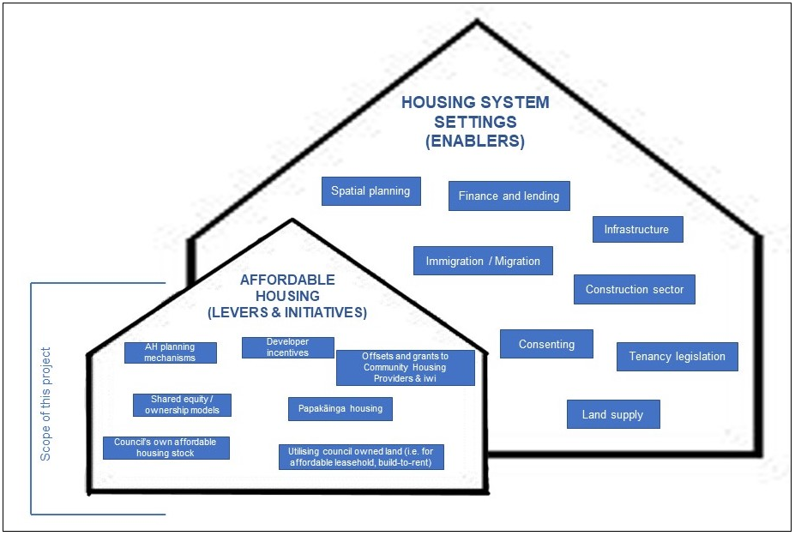

### Problem definition

### *Growing numbers of Aucklanders are trapped in the ‘intermediate housing market’: rental costs are unaffordable, and they are unable to buy their own home*

1. Affordable housing is defined as ‘a home that a household could occupy for less than 30 per cent of its income whether purchasing or renting’.
2. This definition summarises the relationship between household incomes and the prices (or rents) of homes. Prices and rents in turn reflect the balance between demand for, and supply of homes.
3. Over 40 percent of Auckland households now rent. 30 per cent of renting households spend more than that 30 per cent of their income on housing, and three quarters of them cannot afford to buy their own home. They are ineligible for social housing and are stuck in the intermediate housing market.
4. Multiple factors are causing the decline in housing affordability. Global financial trends, immigration and tax policy have all contributed to a rapid increase in demand for houses. Meanwhile land use planning, infrastructure provision and consenting, construction sector productivity and capacity, and bank lending criteria have constrained supply. This has led to rapid house price increases which has outstripped growth in Aucklanders’ income.
5. As a result, Māori, Pacific Island people, sole parents and retired renters are forced into lower quality homes, overcrowded situations, and onto the social housing waiting list. There is a sharpening divide in the incomes and wealth of renters and home owners.
6. Broad brush polices are necessary but not enough to alleviate the housing stress experienced by people in the growing intermediate housing market.
7. More targeted policies and programmes common overseas are required to:

* increase the supply of lower cost homes
* assist households in the private rental market
* assist partial or progressive home ownership.

1. Secure, healthy and affordable housing is critical for whānau and tāmariki wellbeing. A lack of affordable housing brings long term costs to wellbeing.
2. The snapshot report highlighted there are no short-term, low-cost solutions to the systemic issues identified and no agency can solve Auckland’s affordable housing problem alone.
3. The snapshot report also identified affordable housing policies and initiatives that warrant further investigation (see Figure 2).

**Figure 2: Policies and initiatives that provide affordable homes for the intermediate market**

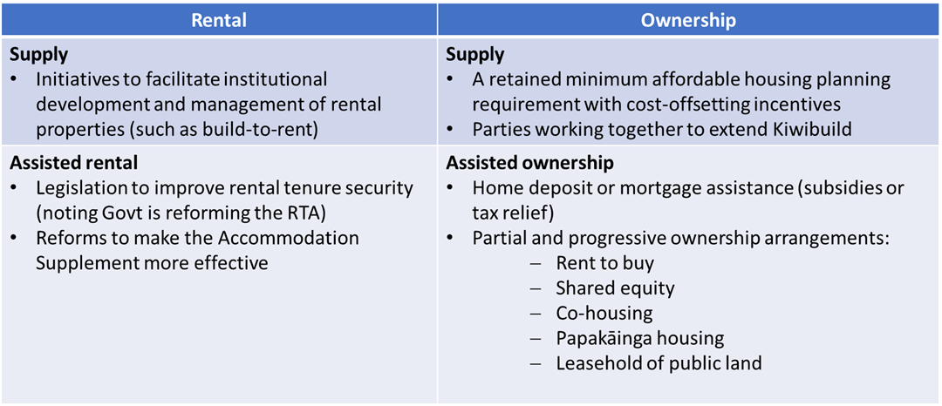

### *Government and council joint work programme on Auckland Housing and Urban Growth*

1. Government plays the principle role in housing policy and the provision of social housing.
2. Many of the housing system settings (or enablers) are controlled by central government or are part of the wider economy. They include:

* immigration policy
* finance legislation and bank lending practices
* tenancy legislation
* construction sector productivity and practice.

1. Government has signaled that the new Housing and Urban Development Authority will consolidate three agencies: Housing New Zealand, HLC (Homes. Land. Community.) and KiwiBuild. This authority may have a range of statutory powers that will impact on the provision of affordable housing and the role of council.
2. Council also influences the wider housing system settings through:

* planning, consenting and building control mechanisms
* provision of infrastructure and development contributions
* utilising council owned land
* partnering and advocacy.

1. Auckland Council and government have developed a Joint Programme on Auckland Housing and Urban Growth to deliver shared housing and urban growth priorities. The committee will consider the joint work programme at this meeting.

*Council can explore levers and initiatives to contribute to the joint work programme with government to get people into affordable homes*

1. There is an affordable housing workstream within the joint government/council programme. Deciding the council position and role will provide clear direction for council’s contribution to the joint affordable housing workstream.

### Current status

### *The Auckland Plan 2050 outcomes set the direction for affordable homes for all*

1. The Auckland Plan 2050 Homes and Places outcome seeks improved housing and rental choices, tenure security and housing quality for Aucklanders (Focus Areas 1,2 and 3).
2. This sets a clear direction for affordable homes for all Aucklanders.
3. Current council activities that support the aspiration of affordable homes include:

* ‘transform’ and ‘unlock’ to deliver a mix of housing types on council surplus land
* Haumaru housing portfolio delivers affordable rental housing for older people
* under the Contributions Policy 2019 “social housing developers” are offered extended payment times for development contributions on a case by case basis (CP2018/24409)
* work with government and non-government partners to develop and implement a regional cross sectoral homelessness plan - Kia Whai Kāinga Tātou Katoa
* economic modelling and research on development feasibility
* grants, assistance to Iwi/Māori trusts to support Papakāinga and Māori housing
* support in principle for the Kāinga Strategic Action Plan.

### *Stakeholders believe council can play a stronger role in affordable housing*

1. Engagement for this report took place with advisory staff from:

* Ministry of Housing and Urban Development
* Independent Māori Statutory Board (IMSB)
* Property Council
* Auckland Community Housing Providers Network
* Te Matapihi he tirohanga mō te iwi Trust (a Māori housing organisation).

1. Stakeholders supported an enhanced role for council in affordable housing and signalled a willingness to work with council on affordable housing solutions.
2. Community housing providers play a key role in managing retained affordable housing. At a workshop with the Auckland Community Housing Providers Network in January 2019 they gave three examples of where council could take a stronger role:

* the strategic use of council assets (Barrowcliffe Place is an example of effective partnership between council, Panuku, community housing providers and iwi)
* changes to the Auckland Unitary Plan to include inclusionary zoning for (retained) affordable housing
* reviewing the costs of development contributions and consenting fees for community housing providers delivering affordable housing.

**Tātaritanga me ngā tohutohu**

# Analysis and advice [guidance](https://acintranet.aklc.govt.nz/EN/workingatcouncil/techandtools/infocouncil/Pages/AnalysisAndAdvice.aspx)

### Options for Auckland Council’s position and role in affordable housing

1. Four options on the council position and role have been assessed by staff and three are presented for consideration:

* Option 2 – partner and influence: ‘status quo’ option, where council continues to partner with others and influence government within existing policy and plan settings
* Option 3 – intervene and lead: ‘do more’ option, where council investigates changes to levers (e.g. through an inclusionary zoning provision) and initiatives, and leads partnerships through a strengthened collaborative approach
* Option 4 – directly deliver: ‘do a lot more’ option, with council becoming a direct provider of affordable housing.

1. Option 1 – statutory requirements would involve doing less than the status quo. It is the least responsive to the affordable housing problem and has not been presented for consideration.
2. Each option incorporates the option before and increases the role for council in addressing affordable housing. The cost and complexity of implementation increases with each option (see Figure 3). Implementation of specific affordable housing initiatives would be subject to future decision-making.

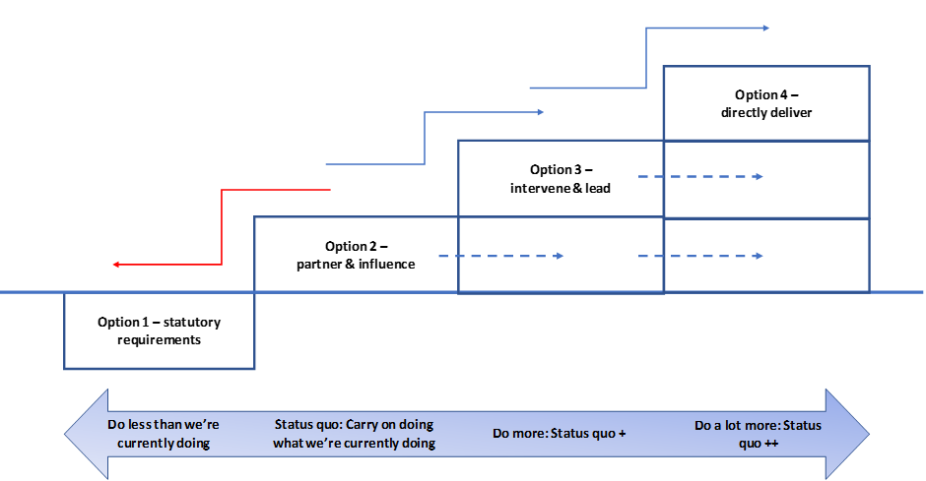

**Figure 3: Options for position and role on affordable housing**

**Option 2 – Position: partner and influence**

1. Option 2 - partner and influence: ensures council is working towards the Auckland Plan 2050 outcomes and enhances its contribution to affordable housing through partnerships and influence. Current work and relationships provide a platform for further work on affordable housing problems and initiatives.

|  |  |
| --- | --- |
| **Role** | Continue with current activities - use current work programme to partner with central government and others on a case-by-case basis. This is the status quo as described in paragraph 34. |
| **Strengths** | * Goes some way to enhancing and improving affordable housing outcomes. * Processes to deliver are already in place, and council has the capacity and capability to continue. * Potential new partnering opportunities. |
| **Risks** | * Impact on affordable housing outcomes over the longer term is unknown, and current work is unlikely to be enough to address the current problem. * Does not meet partner expectations for council to do more. |

**Option 3 – Position: intervene and lead**

1. Option 3 - intervene and lead: would require council to maintain the status quo and begin the process of strengthening levers and initiatives (policy, planning, controls, budgets, council land and incentives). Council would form stronger partnerships and lead in some areas. This option would leverage existing capability in council.

|  |  |
| --- | --- |
| **Role** | Option 2 + strengthen levers and initiatives, and further develop and lead partnerships. This would include investigating:   * modelling inclusionary zoning, other planning mechanisms and incentives * improving council processes for affordable housing outcomes * concessions or grants for community housing providers * partnerships with government, iwi, community housing providers and developers * retained affordability mechanisms and rental tenure security for renters * the experience and needs of people in the intermediate housing market. |
| **Strengths** | * Greater impact on affordable housing outcomes and the problem. * Council has the capability to analyse, model and design policy and plan changes. * Strong support from partners for council to do more. |
| **Risks** | * Impact on affordable housing outcomes is unknown. * Potential opposition to council investigating inclusionary zoning. * Any future regulatory work i.e. inclusionary zoning may be complex and time consuming with high cost. |

**Option 4 – Position: directly deliver**

1. Option 4 - directly deliver: council would assess and decide what services to deliver to be directly involved in affordable housing provision in partnership with others. This is balanced by high potential costs for delivery (in a financially constrained environment).

|  |  |
| --- | --- |
| **Role** | Option 3 + directly provide affordable and social housing through changes to the planning mechanisms and controls in the Long-term Plan 2018-2028. This would involve doing a lot more, and would include investigating:   * purchasing, or making existing council land available for affordable housing * delivery of social housing directly, through subsidies/incentives to community housing providers * supporting progressive home ownership schemes such as rent-to-buy, shared equity or co-housing * partnerships to deliver build-to-rent developments. |
| **Strengths** | * More levers to have a greater direct impact on affordable housing outcomes. * Leverages existing asset base (landholdings within our control). * Community housing providers support a strengthened partnership. * International evidence suggests a strong partnership model between local and central government and the non-governmental sector offers a promising opportunity to deliver affordable housing at scale. |
| **Risks** | * As a new service, costs to council are unknown, but would be high. * Requires significant budget through future Annual Plan or Long-term Plan and significantly changes to Panuku mandate * Significant investigative work would be required to understand costs and benefits, including alternative sources of funding. Seeking funding from private capital markets to invest could bring additional risks. * Time would need to be invested in strengthening partnerships. * May encroach on central government’s role in housing provision. * Community housing providers may have limited capacity to manage a large affordable housing portfolio. |

1. The options are assessed in Table 1 below against the following criteria:

* *impact on delivering affordable housing:* contribution to provision of affordable housing
* *managing complexity*: tools and approaches that respond to system complexity
* *opportunities for collaboration:* meaningful collaboration with partners to deliver affordable housing solutions
* *flexibility of approach*: flexibility to respond to new opportunities or take new directions if/when government and/or market conditions shift
* *cost effectiveness:* good value for the potential cost of implementation.

1. The criteria have been developed from the snapshot report analysis and engagement with stakeholders. The criteria reflect those variables that were considered critical in delivering affordable housing for all Aucklanders within the current uncertain context.

Table 1: Assessment of options against criteria

|  |  |  |  |
| --- | --- | --- | --- |
| Criteria | Option 2 - Partner and influence | Option 3 - Intervene and lead | Option 4 - Directly deliver |
| Impact in delivering affordable housing | ✓ | ✓✓ | ✓✓✓ |
| Managing complexity | ✓✓ | ✓✓ | ✓✓✓ |
| Opportunities for collaboration | ✓✓ | ✓✓✓ | ✓✓✓ |
| Flexibility of approach | ✓ | ✓✓✓ | ✓✓ |
| Cost effectiveness | ✓✓ | ✓✓ | ✓ |
| Key  Alignment with criteria | Low  ✓ | Medium  ✓✓ | High  ✓✓✓ |

### *Staff recommend Option 3 – intervene and lead to increase council’s contribution towards addressing affordable housing*

1. Option 2 - partner and influence, has the lowest cost, but the least impact on the problem, and overall lowest alignment with the criteria. It is not recommended.
2. Options 3 - intervene and lead, and Option 4 - directly deliver, have the same overall alignment when scored against the criteria.
3. The Independent Māori Statutory Board’s Kāinga Strategic Action Plan identifies outcomes that would improve the supply and quality of affordable housing for Māori and actions for Auckland Council. Implementing these actions will be explored in the next phase of work, should council endorse Option 3 - intervene and lead, or Option 4 – directly deliver.
4. The key trade-off between the two options is the potential cost.
5. Option 4 – directly deliver, signals to the community that council will take a big step up from the current approach. It has greater direct impact on affordable housing, but there is greater cost and uncertainty about implementation.
6. Staff recommend Option 3 - intervene and lead. This means continuing and increasing our current activities through investigating levers and initiatives, including inclusionary zoning. This option allows us to increase our impact on the affordable housing problem within our current capability and with greater certainty about potential costs. It presents a managed progression towards increasing our impact and provides flexibility for council to step towards Option 4 - direct delivery, in the future.

**Ngā whakaaweawe me ngā tirohanga a te rōpū Kaunihera**

## Council group impacts and views [guidance](https://acintranet.aklc.govt.nz/EN/workingatcouncil/techandtools/infocouncil/Pages/CouncilGroupImpactsAndViews.aspx)

1. The impact on the council group depends on both the position and role selected. Option 3 - intervene and lead, and Option 4 – directly deliver, represent the greatest potential future impact on existing council group roles.
2. The nature and scale of impact will be determined by future council decision-making about levers and initiatives to implement the preferred position and role.

**Ngā whakaaweawe ā-rohe me ngā tirohanga a te poari ā-rohe**

## Local impacts and local board views [guidance](https://acintranet.aklc.govt.nz/EN/workingatcouncil/techandtools/infocouncil/Pages/LocalImpactsAndLocalBoardViews.aspx)

1. Affordable housing is a critical issue across Tāmaki Makaurau. Making more affordable housing available in Tāmaki Makaurau will have a positive impact, particularly in local board areas with high numbers of people trapped in the intermediate housing market.

**Tauākī whakaaweawe Māori**

## Māori impact statement [guidance](https://acintranet.aklc.govt.nz/EN/workingatcouncil/techandtools/infocouncil/Pages/MaoriImpactState.aspx)

1. Affordable housing is a critical issue for Māori. Māori rates of home ownership have declined over the past 25 years and Māori are much more likely than European/Pākeha to be renters in Tāmaki Makaurau.
2. The snapshot report discussed the continual displacement of Māori on the housing ladder: as more affluent households are renting, some whānau are displaced into insecure, unhealthy rental housing and are at risk of continued transience and homlessness.
3. Making more affordable housing available in Tāmaki Makaurau, particularly good quality rental accommodation, will have a significant impact on Māori wellbeing. Focus area 4 of the Homes and Places outcome in Auckland Plan 2050 identifies investing in and supporting Māori to meet their housing aspirations.
4. Māori make up over half of the client base of community housing providers but the number and size of Māori community housing providers is very small. Growing their number, size and capability could be a focus activity of future partnership building with the sector.

**Ngā ritenga ā-pūtea**

## Financial implications [guidance](https://acintranet.aklc.govt.nz/EN/workingatcouncil/techandtools/infocouncil/Pages/FinancialImplications.aspx)

1. The financial implications for council of the options identified are:

* Option 2 - partner and influence: activities are within existing budget
* Option 3 - intervene and lead: investigation work is within current budget and implementation of future initiatives with financial implications can be considered through future Annual Plan and Long-term Plan processes
* Option 4 - directly deliver: investigation work within current budget. Potential for new services with significant budget implications requiring business case development. Funding considered through future Annual Plan and Long-term Plan processes.

**Ngā raru tūpono me ngā whakamaurutanga**

## Risks and mitigations [guidance](https://acintranet.aklc.govt.nz/EN/workingatcouncil/techandtools/infocouncil/Pages/Risks.aspx)

1. Risks and mitigation measures for the recommended Option 3 – intervene and lead are:

|  |  |  |
| --- | --- | --- |
| Risk identified | (High/ Medium/ Low) | Mitigation |
| There is an implementation risk that any future planning changes may be controversial, complex and costly. | M | Complexity of implementation and the costs of these initiatives will be addressed in the investigation and modelling work. |
| There is a reputational risk that if investigated initiatives do not progress, council will be criticised for raising expectations, and not implementing its preferred position and role. | M | Engagement with stakeholders and communication with Aucklanders during the investigation of initiatives. |

**Ngā koringa ā-muri**

# Next steps [guidance](https://acintranet.aklc.govt.nz/EN/workingatcouncil/techandtools/infocouncil/Pages/NextSteps.aspx)

1. The next steps for the recommended Option 3 – intervene and lead are:

1. If Option 4 - directly deliver is chosen, staff will report back in July 2019 with a work programme scope and timeline for implementation decision-making.
2. Specific initiatives will be considered by the appropriate committee for decision-making.
3. Updates will be provided as part of the progress reporting for the Joint Programme on Auckland Housing and Urban Growth.

**Ngā tāpirihanga**

# Attachments [guidance](https://acintranet.aklc.govt.nz/EN/workingatcouncil/techandtools/infocouncil/Pages/Attachments.aspx)

There are no attachments for this report.

**Ngā kaihaina**

# Signatories

|  |  |
| --- | --- |
| Authors | Peter Chaudhry - Principal Policy Analyst |
| Authorisers | Deborah Edwards - Senior Policy Manager  Kataraina Maki - GM - Community & Social Policy  Megan Tyler - Chief of Strategy |